I233018
AbdulBasit
LAB6

Question2:
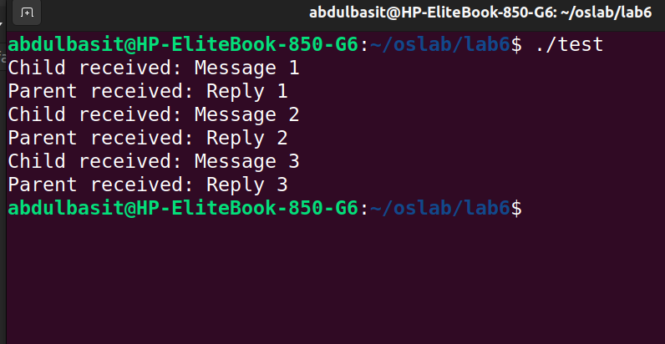
Code:

#include <stdio.h>
#include <stdlib.h>
#include <unistd.h>
#include <sys/wait.h>
#include <string.h>

int main()
{
int pipe1[2];
int pipe2[2];
pid_t pid;
char parent_msg[] = "Message";
char child_msg[] = "Reply";
char buf[100];

if (pipe(pipe1) == -1)
{
printf("Error creating pipe1\n");
exit(1);
}

if (pipe(pipe2) == -1)
{
printf("Error creating pipe2\n");
exit(2);
}

pid = fork();

if (pid == -1)
{
printf("Error creating process\n");
exit(3);
}

if (pid == 0) // Chil#include <stdio.h>
#include <stdlib.h>
#include <unistd.h>
#include <sys/wait.h>
#include <string.h>

int main()
{
int pipe1[2];
int pipe2[2];
pid_t pid;
char parent_msg[] = "Message";
char child_msg[] = "Reply";
char buf[100];

if (pipe(pipe1) == -1)
{
printf("Error creating pipe1\n");
exit(1);
}

if (pipe(pipe2) == -1)
{
printf("Error creating pipe2\n");
exit(2);
}

pid = fork();

if (pid == -1)
{
printf("Error creating process\n");
exit(3);
}

if (pid == 0) // Child process
{
close(pipe1[1]); // Close write end of pipe1
close(pipe2[0]); // Close read end of pipe2
for(int i=0;i<3;i++)
{
ssize_t bytesRead = read(pipe1[0], buf, sizeof(buf) - 1);
if (bytesRead == -1)#include <stdio.h>
#include <stdlib.h>
#include <unistd.h>
#include <sys/wait.h>
#include <string.h>

int main()
{
int pipe1[2];
int pipe2[2];
pid_t pid;
char parent_msg[] = "Message";
char child_msg[] = "Reply";
char buf[100];

if (pipe(pipe1) == -1)
{
printf("Error creating pipe1\n");
exit(1);
}

if (pipe(pipe2) == -1)
{
printf("Error creating pipe2\n");
exit(2);
}

pid = fork();

if (pid == -1)
{
printf("Error creating process\n");
exit(3);
}

if (pid == 0) // Child process
{
close(pipe1[1]); // Close write end of pipe1
close(pipe2[0]); // Close read end of pipe2
for(int i=0;i<3;i++)
{
ssize_t bytesRead = read(pipe1[0], buf, sizeof(buf) - 1);
if (bytesRead == -1)
{
printf("Error reading from pipe1\n");
exit(4);
}
buf[bytesRead] = '\0';
printf("Child received:%s %d\n", buf,i+1);

ssize_t bytesWritten = write(pipe2[1], child_msg, sizeof(child_msg));
if (bytesWritten == -1)
{
printf("Error writing to pipe2\n");
exit(5);
}
}

close(pipe1[0]); // Close read end of pipe1
close(pipe2[1]); // Close write end of pipe2
exit(0);
}
else // Parent process
{
close(pipe1[0]); // Close read end of pipe1
close(pipe2[1]); // Close write end of pipe2
for(int i=0;i<3;i++)
{
ssize_t bytesWritten = write(pipe1[1], parent_msg, sizeof(parent_msg));
if (bytesWritten == -1)
{
printf("Error writing to pipe1\n");
exit(6);
}

ssize_t bytesRead = read(pipe2[0], buf, sizeof(buf) - 1);
if (bytesRead == -1)
{
printf("Error reading from pipe2\n");
exit(7);
}
buf[bytesRead] = '\0';
printf("Parent received:%s %d\n", buf,i+1);
}
close(pipe1[1]); // Close write end of pipe1
close(pipe2[0]); // Close read end of pipe2
wait(NULL); // Wait for child process to finish
exit(0);
}
}
{
printf("Error reading from pipe1\n");
exit(4);
}
buf[bytesRead] = '\0';
printf("Child received:%s %d\n", buf,i+1);

ssize_t bytesWritten = write(pipe2[1], child_msg, sizeof(child_msg));
if (bytesWritten == -1)
{
printf("Error writing to pipe2\n");
exit(5);
}
}

close(pipe1[0]); // Close read end of pipe1
close(pipe2[1]); // Close write end of pipe2
exit(0);
}
else // Parent process
{
close(pipe1[0]); // Close read end of pipe1
close(pipe2[1]); // Close write end of pipe2
for(int i=0;i<3;i++)
{
ssize_t bytesWritten = write(pipe1[1], parent_msg, sizeof(parent_msg));
if (bytesWritten == -1)
{
printf("Error writing to pipe1\n");
exit(6);
}

ssize_t bytesRead = read(pipe2[0], buf, sizeof(buf) - 1);
if (bytesRead == -1)
{
printf("Error reading from pipe2\n");
exit(7);
} }
close(pipe1[1]); // Close write end of pipe1
close(pipe2[0]); // Close read end of pipe2
wait(NULL); // Wait for child process to finish
exit(0);
}
}
buf[bytesRead] = '\0';
printf("Parent received:%s %d\n", buf,i+1);
}
close(pipe1[1]); // Close write end of pipe1
close(pipe2[0]); // Close read end of pipe2
wait(NULL); // Wait for child process to finish
exit(0);
}
}

Question3:
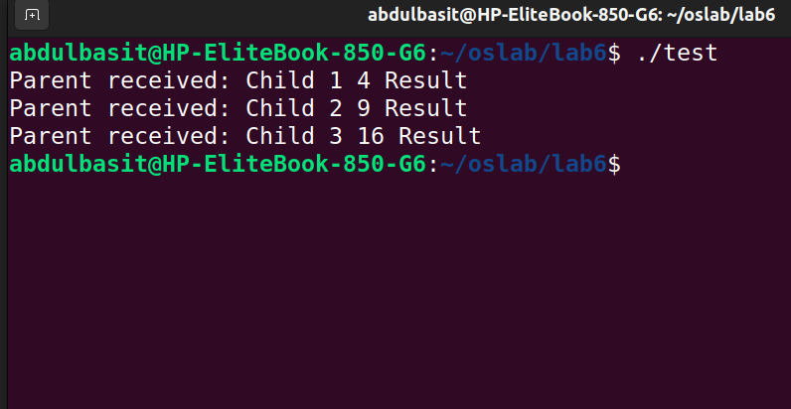

Code:
#include <stdio.h>
#include <stdlib.h>
#include <unistd.h>
#include <sys/wait.h>
#include <string.h>

int main()
{
int pipe1[2];
int pipe2[2];
int pipe3[2];
pid_t pid;
char buf[100];

if (pipe(pipe1) == -1)
{
printf("Error creating pipe1\n");
exit(1);
}

if (pipe(pipe2) == -1)
{
printf("Error creating pipe2\n");
exit(2);
}

if (pipe(pipe3) == -1)
{
printf("Error creating pipe3\n");
exit(3);
}

pid = fork();

if (pid == -1)
{
printf("Error creating process\n");
exit(3);
}

if (pid == 0) // Child 1 process
{
close(pipe1[0]); // Close read end of pipe1
close(pipe2[0]); // Close read end of pipe2
close(pipe3[0]); // Close read end of pipe3

int calculation = 2 * 2; // 2 square
char cal1[12];
sprintf(cal1, "%d", calculation);

ssize_t bytesWritten = write(pipe1[1], cal1, sizeof(cal1));
if (bytesWritten == -1)
{
printf("Error writing to pipe1\n");
exit(5);
}

close(pipe1[1]); // Close write end of pipe1
exit(0);
}
else // Parent process
{
pid_t pid2 = fork();
if (pid2 == -1)
{
printf("Error creating process\n");
exit(3);
}

if (pid2 == 0) // Child 2 process
{
close(pipe1[0]); // Close read end of pipe1
close(pipe2[0]); // Close read end of pipe2
close(pipe3[0]); // Close read end of pipe3

int calculation2 = 3 * 3; // 3 square
char cal2[12];
sprintf(cal2, "%d", calculation2);

ssize_t bytesWritten = write(pipe2[1], cal2, sizeof(cal2));
if (bytesWritten == -1)
{
printf("Error writing to pipe2\n");
exit(5);
}

close(pipe2[1]); // Close write end of pipe2
exit(0);
}
else
{
pid_t pid3 = fork();
if (pid3 == -1)
{
printf("Error creating process\n");
exit(3);
}

if (pid3 == 0) // Child 3 process
{
close(pipe1[0]); // Close read end of pipe1
close(pipe2[0]); // Close read end of pipe2
close(pipe3[0]); // Close read end of pipe3

int calculation3 = 4 * 4; // 4 square
char cal3[12];
sprintf(cal3, "%d", calculation3);

ssize_t bytesWritten = write(pipe3[1], cal3, sizeof(cal3));
if (bytesWritten == -1)
{
printf("Error writing to pipe3\n");
exit(5);
}

close(pipe3[1]); // Close write end of pipe3
exit(0);
}
}

sleep(1);
close(pipe1[1]); // Close write end of pipe1
close(pipe2[1]); // Close write end of pipe2
close(pipe3[1]); // Close write end of pipe3

int childCount = 1;

ssize_t bytesRead = read(pipe1[0], buf, sizeof(buf) - 1);
if (bytesRead == -1)
{
printf("Error reading from pipe1\n");
exit(7);
}
buf[bytesRead] = '\0';
printf("Parent received: Child %d %s Result\n", childCount++, buf);

bytesRead = read(pipe2[0], buf, sizeof(buf) - 1);
if (bytesRead == -1)
{
printf("Error reading from pipe2\n");
exit(7);
}
buf[bytesRead] = '\0';
printf("Parent received: Child %d %s Result\n", childCount++, buf);

bytesRead = read(pipe3[0], buf, sizeof(buf) - 1);
if (bytesRead == -1)
{
printf("Error reading from pipe3\n");
exit(7);
}
buf[bytesRead] = '\0';
printf("Parent received: Child %d %s Result\n", childCount, buf);

close(pipe1[0]); // Close read end of pipe1
close(pipe2[0]); // Close read end of pipe2
close(pipe3[0]); // Close read end of pipe3

exit(0);
}
}

